Light Emitting Diodes

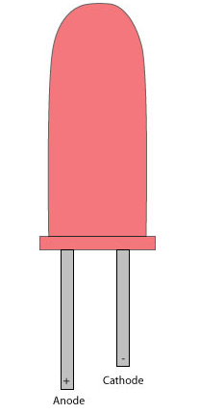

Light Emitting Diodes or LEDs, are among the most widely used of all the types of diodes available. They are the most visible type of diode that emits a fairly narrow bandwidth of either visible coloured light, invisible infra-red or laser type light when a forward current is passed through them. A "Light Emitting Diode" or LED as it is more commonly called, is basically just a specialized type of PN-junction diode, made from a very thin layer of fairly heavily doped semiconductor material. When the diode is Forward Biased, electrons from the semiconductors conduction band combine with holes from the valence band, releasing sufficient energy to produce photons of light. Because of this thin layer a reasonable number of these photons can leave the junction and radiate away producing a coloured light output.
Unlike normal diodes which are made for detection or power rectification, and which are generally made from either Germanium or Silicon semiconductor material, Light Emitting Diodes are made from compound type semiconductor materials such as Gallium Arsenide (GaAs), Gallium Phosphide (GaP), Gallium Arsenide Phosphide (GaAsP), Silicon Carbide (SiC) or Gallium Indium Nitride (GaInN). The exact choice of the semiconductor material used will determine the overall wavelength of the photon light emissions and therefore the resulting colour of the light emitted, as in the case of the visible light coloured LEDs, (RED, AMBER, GREEN etc).
Typical LED Characteristics
Semiconductor  Material | Wavelength | Colour | V_{F} @ 20mA
GaAs | 850-940nm | Infra-Red | 1.2v
GaAsP | 630-660nm | Red | 1.8v
GaAsP | 605-620nm | Amber | 2.0v
GaAsP:N | 585-595nm | Yellow | 2.2v
GaP | 550-570nm | Green | 3.5v
SiC | 430-505nm | Blue | 3.6v
GaInN | 450nm | White | 4.0v
From the table above we can see that the main P-type dopant used in the manufacture of Light Emitting Diodes is Gallium (Ga, atomic number 31) and the main N-type dopant used is Arsenic (As, atomic number 31) giving the resulting Gallium Arsenide (GaAs) crystal structure, which has the characteristics of radiating significant amounts of infrared radiation from its junction when a forward current is flowing through it. By also adding Phosphorus (P, atomic number 15), as a third dopant the overall wavelength of the emitted radiation is reduced to give visible red light to the human eye. Further refinements in the doping process of the PN-junction have resulted in a range of colours available from red, orange and amber through to yellow, and the recently developed blue LED which is achieved by injecting nitrogen atoms into the crystal structure during the doping process.
Light Emitting Diodes I-V Characteristics:
Before a light emitting diode can "emit" any form of light it needs a current to flow through it, as it is a current dependant device. As the LED is to be connected in a forward bias condition across a power supply it should be Current Limited using a series resistor to protect it from excessive current flow. From the table above we can see that each LED has its own forward voltage drop across the PN-junction and this parameter which is determined by the semiconductor material used is the forward voltage drop for a given amount of forward conduction current, typically for a forward current of 20mA. In most cases LEDs are operated from a low voltage DC supply, with a series resistor to limit the forward current to a suitable value from say 5mA for a simple LED indicator to 30mA or more where a high brightness light output is needed.
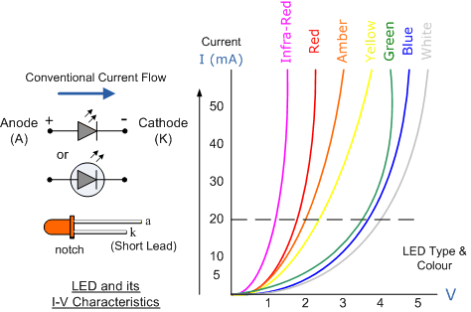
LED Series Resistance:
The series resistor value RS is calculated by simply using Ohm´s Law, knowing the required forward current IF, the supply voltage VS and the expected forward voltage drop of the LED, VF at this current level as shown below:

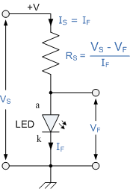
LED Typical Applications:
The following figure shows how to interface the LED to microcontroller. As you can see the Anode is connected through a resistor to Vcc and the Cathode is connected to the Microcontroller pin. So when the Port Pin is HIGH the LED is OFF and when the Port Pin is LOW the LED is turned ON.
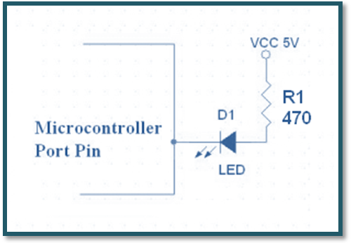

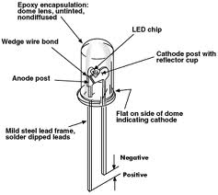
Light emitting diodes (LEDs) are semiconductor light sources. The light emitted from LEDs varies from visible to infrared and ultraviolet regions. They operate on low voltage and power. LEDs are one of the most common electronic components and are mostly used as indicators in circuits. They are also used for luminance and optoelectronic applications.
Based on semiconductor diode, LEDs emit photons when electrons recombine with holes on forward biasing. The two terminals of LEDs are anode (+) and cathode (-) and can be identified by their size. The longer leg is the positive terminal or anode and shorter one is negative terminal.

The forward voltage of LED (1.7V-2.2V) is lower than the voltage supplied (5V) to drive it in a circuit. Using an LED as such would burn it because a high current would destroy its p-n gate. Therefore a current limiting resistor is used in series with LED. Without this resistor, either low input voltage (equal to forward voltage) or PWM (pulse width modulation) is used to drive the LED.

